EXPERIMENT:5: Create a simple cloud software application for Mark Sheet Processing System using any Cloud Service Provider to demonstrate SaaS include the necessary fields such as name of the student, Reg no of the student, Subjects , Marks, Average, percentage, rank, overall performance etc.

STEP:1 CREATE A APPLICATION FORM FOR STUDENT DETAILS.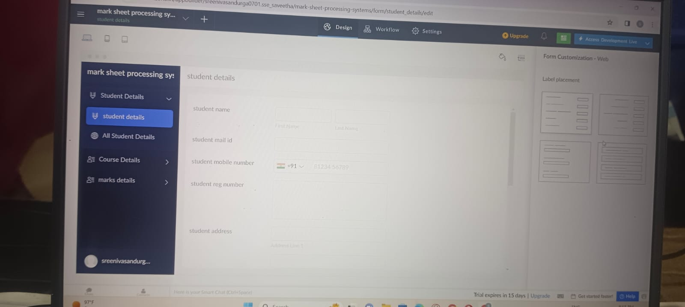

STEP:2 CRAETE A APPLICATION FORM FOR THE COURSE DETAILS.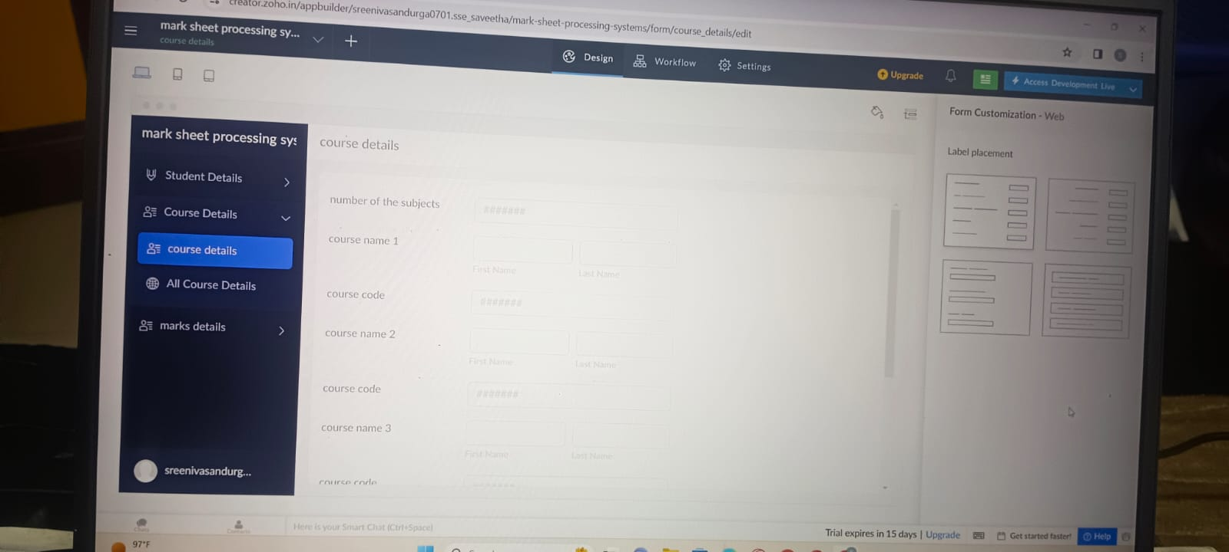

STEP:3:CREATE A APPLICATION FORM FOR THE MARK DETAILS.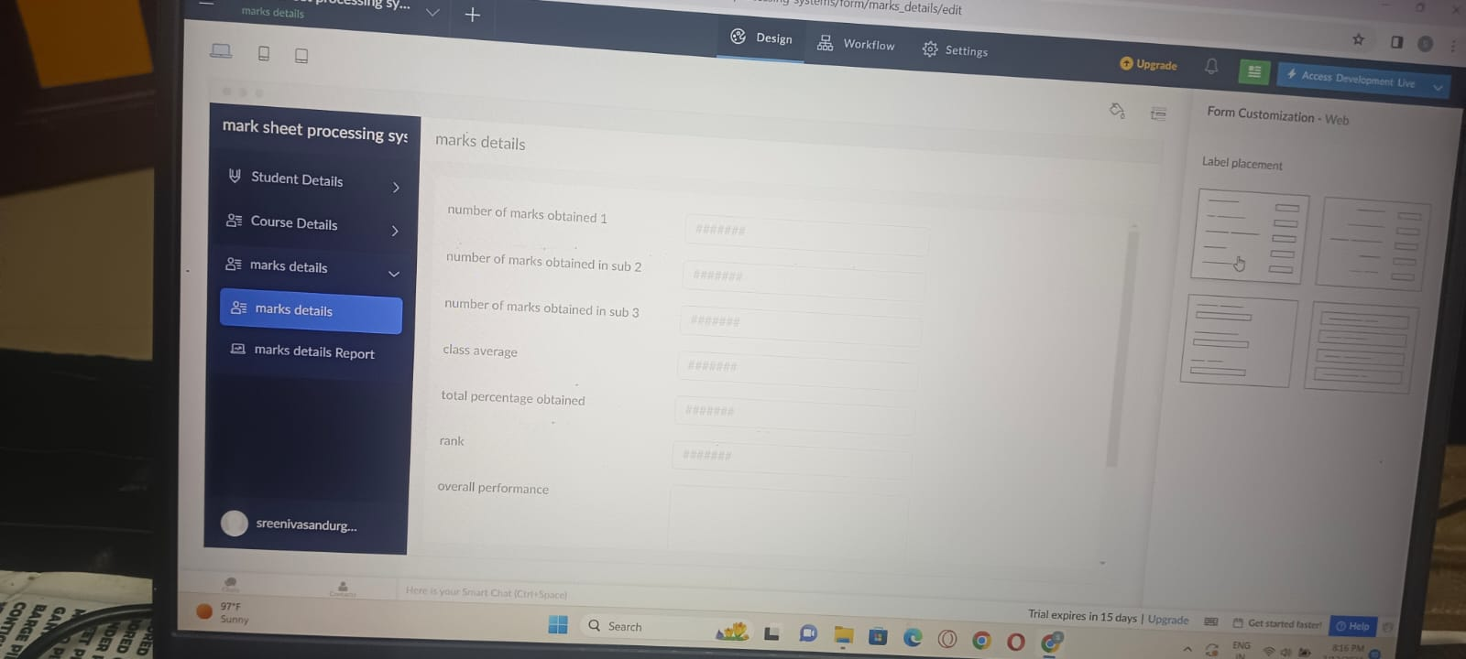

STEP:4: CREATE A APPLICATION FORM FOR THE MARK DETAILS RESULT:

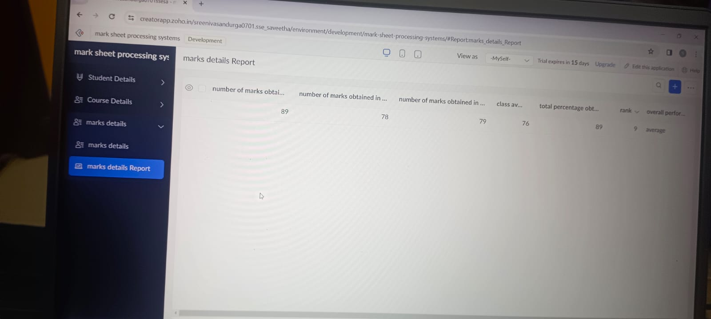

RESULT: THUS, THE PROGRAM FOR THE MARKSHEET PROCESSING SYSTEM HAS BEEN EXCEUTED SUCCESSFULLY.